
Performance Review Report
Engagement analysis, insights and next-cycle strategy
SAMPLE DATA. This report was generated from a fictional person and illustrative figures so you can see the finished format. It is not a real result.

Document control
Project | LinkedIn Influence Lab (Phase 1, 6 weeks)
Project code | LIL-2025-P1
Document | Performance Review Report
Prepared for | Meera Kapoor (Sample), Founder
Learning path | Thought Leader / Entrepreneur
Version / date | 1.1 · 13 November 2026
Classification | Confidential: client use

1. Executive summary
14  Posts analysed | 55,559  Impressions | 2884  Likes | 486  Comments | 6.48%  Engagement rate

Across 14 posts the profile earned 55,559 impressions at an engagement rate of 6.48%. The strongest pillar was Career Insights (7.1%) and the strongest format was Poll (6.6%). The weekly engagement rate moved -5% from the first to the latest week.

2. Performance charts
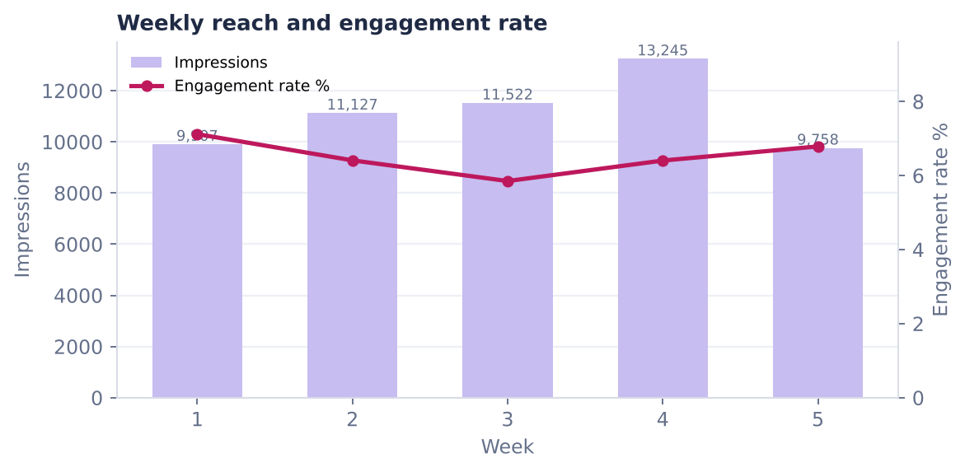
Figure 1. Weekly reach and engagement rate
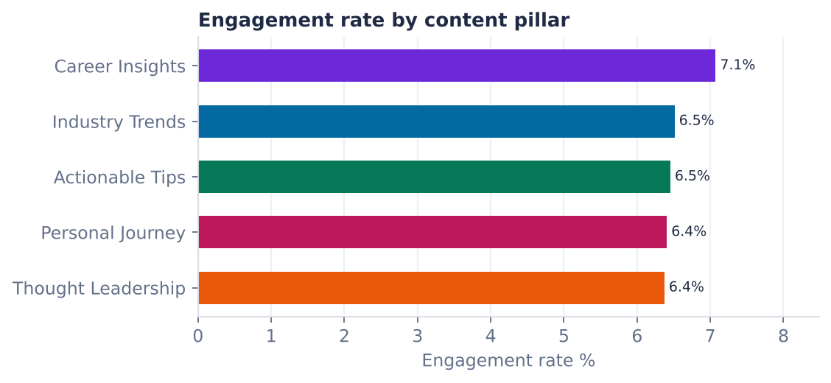
Figure 2. Engagement rate by content pillar
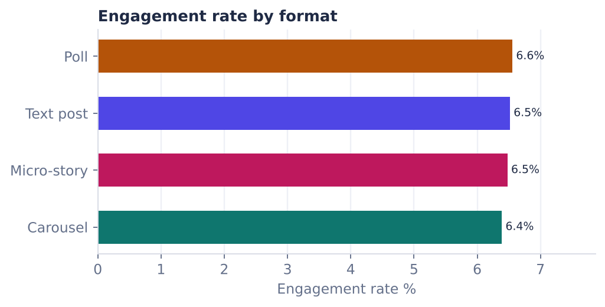
Figure 3. Engagement rate by post format

3. Top performing posts
Post | Pillar | Format | Impressions | Engagement | Rate %
D14 | Industry Trends | Carousel | 4,866 | 338 | 6.9
D10 | Personal Journey | Text post | 4,803 | 326 | 6.8
D13 | Actionable Tips | Text post | 4,892 | 324 | 6.6
D12 | Thought Leadership | Carousel | 4,341 | 292 | 6.7
D05 | Career Insights | Poll | 3,718 | 263 | 7.1

4. Thought Leader / Entrepreneur KPIs
Weekly path KPI | Logged | Six-week target | Progress
Followers gained | 185 | 150 | 100%
Inbound leads | 6 | 6 | 100%
Collaboration / speaking invitations | 2 | 2 | 100%

5. Insights and recommendations
What we saw | What to do next
'Career Insights' is your strongest pillar (7.1% engagement). | Raise its share of the next calendar by about 10 points; keep the others for range.
Poll posts perform best (6.6%). | Use this format at least twice a week; test a new hook style inside it.
Tuesday posts lead on engagement. | Move one more post to Tuesday (same time of day) and compare.
Engagement rate is down 5% from first to latest week. | Review the latest week's hooks against the first week's winners.
1.9% of impressions became profile visits. | Make sure the headline and Featured section convert those visits (see the audit).
3.3 followers gained per 1,000 impressions; 6 inbound leads. | Double down on the format that earned the most shares and end it with a clear next step.

6. Strategy refinement: next six-week pillar mix
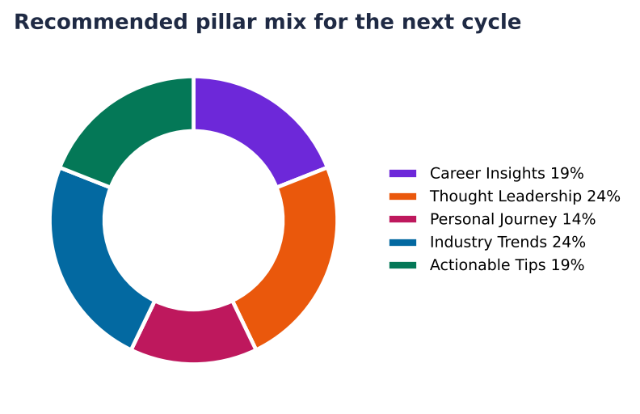
Figure 4. Recommended pillar mix (best pillar +10 points, weakest -5)

7. Self-assessment against the evaluation criteria
Criterion | Weight | Score
Content Quality & Relevance | 30% | 91.3
Consistency of Posting | 25% | 100.0
Engagement Growth | 20% | 47.7
Personal Branding Alignment | 15% | 95.0
Documentation & Clarity | 10% | 100.0
Overall |  | 86.2

8. Risks and mitigations
Risk | Mitigation (brief) | How this project handles it
Low engagement | Adjust posting time and content type | The insights flag a rate below 2% and suggest hook, format and time tests.
Free-tier limits in Taplio | Supplement with manual LinkedIn analytics | Manual entry and a flexible CSV importer for LinkedIn or Taplio exports.
Over-reliance on AI | Ensure human review for authenticity | A Human reviewed gate on every draft; only approved posts enter the approved-only Taplio queue.
Consistency drop-off | Use scheduling to avoid gaps | Taplio queue, .ics reminders, and a consistency score and streak on the dashboard.

